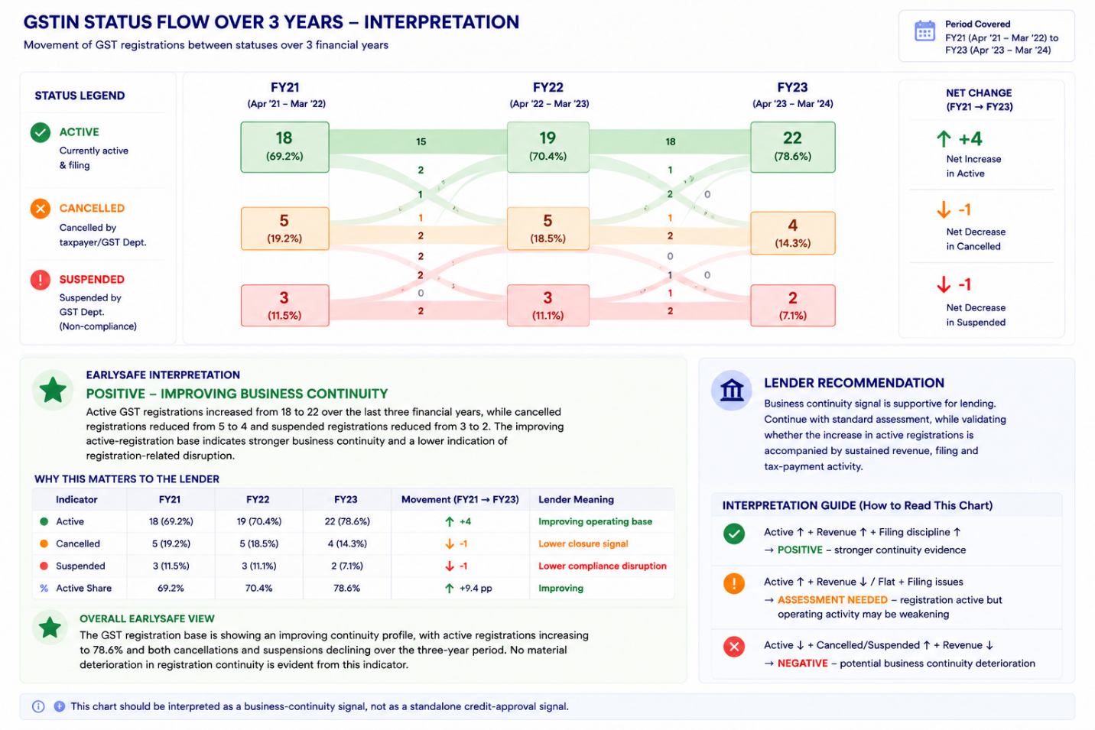
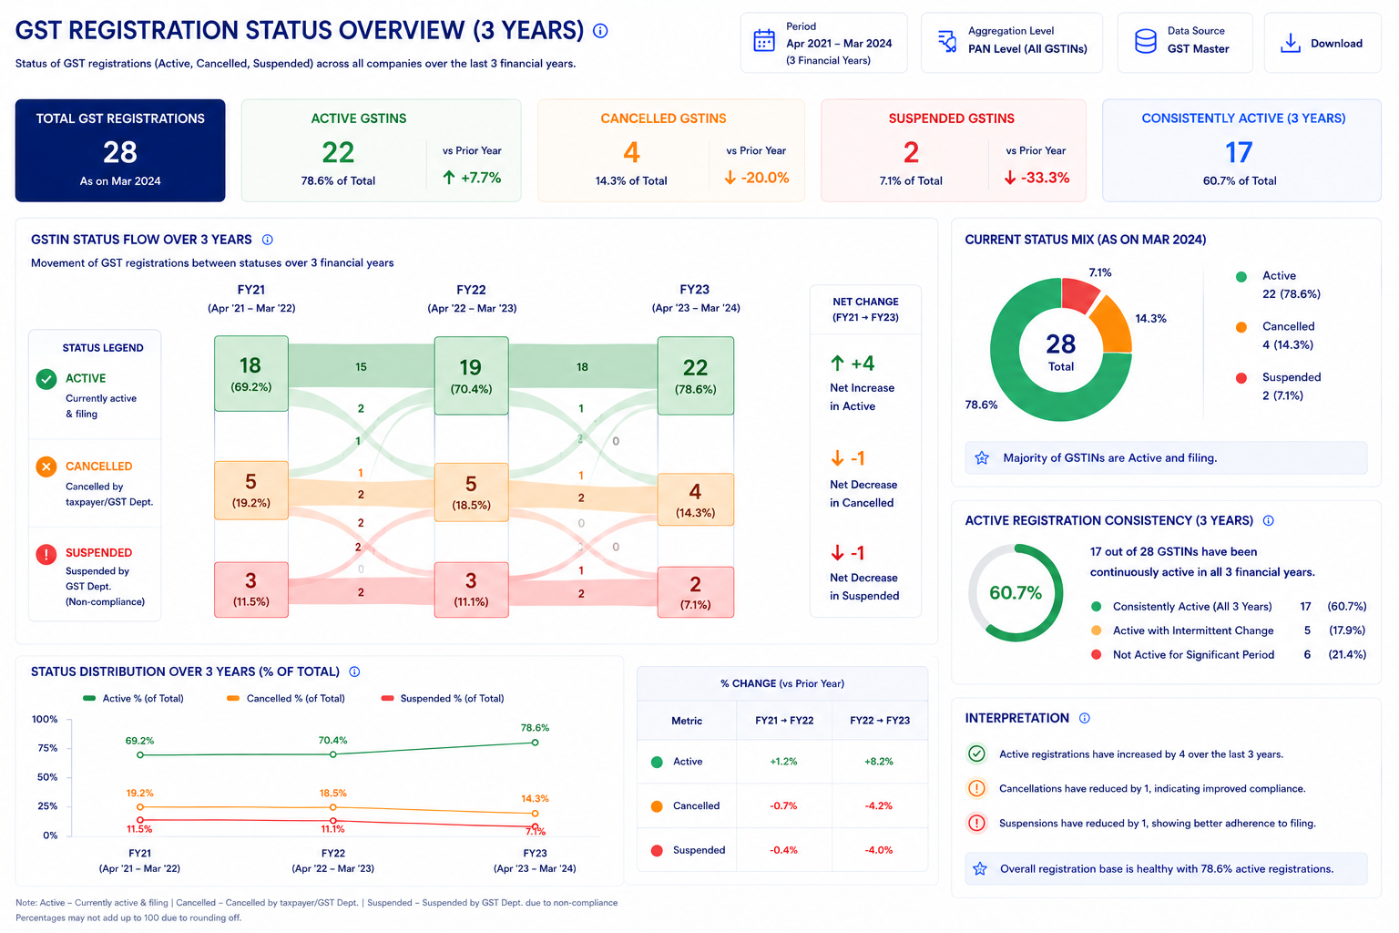

- REGISTRATION STATUS
What is the chart for?
- This chart shows the GST registration status of the company over the last 3 financial years.
- It helps the user understand how the company's GST registrations have changed over time.
- It shows whether GST registrations are:
- Active
- Cancelled
- Suspended
2. Which data will be used?
- The data will be picked from GSTREG1.
- First identify the Company PAN.
- Find all GSTINs linked to that PAN.
- Check the registration status of each GSTIN for each financial year.
- The GSTIN-level status is then combined to create the company-level view.
3. What does each status mean?
Active
- GST registration is currently active.
- The GSTIN is considered operational from the registration-status perspective.
Cancelled
- GST registration has been cancelled.
- The cancellation may be by the taxpayer or by the GST department, as represented in the source data.
Suspended
- GST registration has been suspended.
- This represents a registration that is temporarily not active due to the suspension status.

4. What does the chart show?
The chart compares the registration status across:
- FY21 — Apr 2021 to Mar 2022
- FY22 — Apr 2022 to Mar 2023
- FY23 — Apr 2023 to Mar 2024
For every year, show:
- Number of Active GSTINs
- Number of Cancelled GSTINs
- Number of Suspended GSTINs
- Percentage of total GSTINs

5. Total GSTIN count
- The system should identify the GSTINs belonging to the Company PAN.
- For each financial year, determine the status of those GSTINs.
- The total number of GSTINs represented in that year's status view should be clearly defined based on the available GSTREG1 status records

6. Flow between years
- The flow between FY21 → FY22 → FY23 shows how GSTINs moved from one status to another.
- This allows the user to see whether registrations:
- Remained active
- Became cancelled
- Became suspended
- Returned to another status, where supported by the data

7. Net change (it will be visible on hovering )
The right side of the chart shows the overall change between the first and last financial year.
It should show:
- Net change in Active GSTINs
- Net change in Cancelled GSTINs
- Net change in Suspended GSTINs
This gives the user a quick understanding of whether the company's registration position has improved or deteriorated.

8. Percentage calculation
For each financial year:
Status % = Number of GSTINs in that Status across pan ÷ Total GSTINs considered for that Financial Year across pan × 100

The same calculation should be applied separately for:
- Active
- Cancelled
- Suspended

10. Important point about the flow
- The system should not only show the total number of Active/Cancelled/Suspended GSTINs.
- It should also track how individual GSTINs moved between statuses from one financial year to the next.
- This is what creates the flow/Sankey view.
So the logic is:
FY21 GSTIN Status → FY22 GSTIN Status → FY23 GSTIN Status

11. Drill-down when the user clicks a status
When the user clicks a particular status, such as Active, the system should show the GSTINs included in that category.
For example:
FY23 → Active
↓
List of Active GSTINs
The user should then be able to see the relevant GSTIN details from GSTREG1 in tabular format.

12. Missing data handling
- The backend should check whether GSTREG1 status data is available for the GSTINs being analysed.
- If data is missing for any GSTIN or period, it should not automatically be treated as Cancelled or Suspended.
- Missing information should remain NULL.
- The system should identify the GSTINs for which status information is unavailable.
- If required, the same Fetch Data / Continue Anyway operational flow can be applied.
13. If user clicks "Fetch Data"
- Redirect to Operational Status / Data Fetching.
- Show the GSTIN and missing data source.
- Allow the missing GSTR-2B/GSTR-3B data to be fetched.
- Once the data is available, the chart should be updated.
14. If user clicks "Continue Anyway"
- Continue showing the chart using available data.
- Missing values should remain NULL.
- Missing data must not be treated as zero.
- The system should indicate that the displayed result may be incomplete.

15. Frontend display
- The current chart is designed for a 3-year view, where the Sankey flow remains readable.
- If a longer historical period is introduced later, the frontend should adjust the presentation so that the flow does not become crowded.
- The underlying GSTIN-level status history should still be retained for drill-down.

REST WILL BE SAME FOR THE LOAN LEVEL CALCULATION

Data will be presented on yearly basis only no need of halfyearly filter and quarterly filter

18. filter option should be visible in every chart on top right corner where the option will be in 2nd view
- Past 1 year
- Past 3 year
- Past 5 year
by selecting these the data will be visible as per the filter otherwise it will be remain as

Active Filing behavior

On-Time Filing Behavior — Detailed Explanation
1. Purpose of the Chart
- The On-Time Filing Behaviour chart shows how consistently the company files its GST returns within the prescribed filing timeline.
- It helps the user understand whether the company's GST filing discipline is:
  - Improving
  - Stable
  - Declining
- The chart is calculated at the company level, using all relevant GSTINs mapped to the PAN.
- The current view is Half-Yearly.

2. Data Source: GSTR-1 (will be picked from Delay indicator)
The backend will use the filing records of all applicable GSTR-1 returns for GSTINs mapped to the company.

3. Main Metric — On-Time Filing %
The chart displays:
On-Time Filing (%)
This represents the percentage of applicable GSTR-1 returns that were filed on or before their due date.
Formula
- On-Time Filing % = (Number of GSTR-1 returns filed on or before the due date ÷ Total applicable GSTR-1 returns) × 100

- Company On-Time Filing % = Total On-Time GSTR-1 Returns across all GSTINs ÷ Total Applicable GSTR-1 Returns across all GSTINs × 100

The calculation should be performed separately for every selected period.

6. Half-Yearly View
The chart currently displays six half-year periods:
- Apr–Sep
- Oct–Mar
- Apr–Sep
- Oct–Mar
- Apr–Sep
- Oct–Mar
For each half-year:
H1
April to September
H2
October to March
The backend aggregates all applicable GSTR-1 filing records falling within that period.
Formula for each half-year

If someone clicks on half yearly data it bifurcates into the respective months.

7. What the Trend Shows
The chart should allow the user to see the movement in filing discipline over time.
The current chart displays:
- 90%
- 88%
- 77%
- 79%
- 82%
- 80%
The important information is the trend, not only the individual percentage.
The system should identify:
- Improvement in filing discipline
- Decline in filing discipline
- Stable filing behaviour
- Recovery after a decline
- Persistent deterioration

8. Period-on-Period Change
The backend should calculate the movement from the previous period.
Formula
Filing Change % =
(Current On-Time Filing % − Previous On-Time Filing %) ÷ Previous On-Time Filing % × 100
The UI can represent this as:
- ↑ Improvement
- ↓ Decline
- → Stable
This allows the user to understand whether filing behaviour has improved or deteriorated.

9. Year-on-Year Comparison
The system should also support financial-year comparison.
Financial-Year On-Time Filing %
FY On-Time Filing % =
Total On-Time GSTR-1 Filings in FY ÷ Total Applicable GSTR-1 Filings in FY × 100
Then:
YoY Change
YoY Change = Current FY On-Time Filing % − Previous FY On-Time Filing %
This helps determine whether the company's overall filing discipline is improving or worsening year over year.

10. Historical Period Selection
The chart should support different historical periods.
Recommended options:
- Last 1 Year
- Last 3 Years
- Last 5 Years
The frontend should change the display granularity depending on the selected period.
Historical Period | Recommended View
Last 1 Year | Quarterly
Last 3 Years | Half-Yearly
Last 5 Years | Yearly

11. Hover Information
When the user hovers over a particular point, the tooltip should provide more detail.
It should show:
- Financial Period
- On-Time Filing %
- % change

12. Missing data handling
- The backend should check whether GSTREG1 status data is available for the GSTINs being analysed.
- If data is missing for any GSTIN or period, it should not automatically be treated as Cancelled or Suspended.
- Missing information should remain NULL.
- The system should identify the GSTINs for which status information is unavailable.
- If required, the same Fetch Data / Continue Anyway operational flow can be applied.
13. If user clicks "Fetch Data"
- Redirect to Operational Status / Data Fetching.
- Show the GSTIN and missing data source.
- Allow the missing GSTR-2B/GSTR-3B data to be fetched.
- Once the data is available, the chart should be updated.
14. If user clicks "Continue Anyway"
- Continue showing the chart using available data.
- Missing values should remain NULL.
- Missing data must not be treated as zero.
- The system should indicate that the displayed result may be incomplete.

REST WILL BE SAME FOR THE LOAN LEVEL

Geographic concentration

Geographic Concentration — Detailed Analysis

1. Purpose of the use case
- This use case shows how the company's overall business is distributed across different states.
- The calculation is done at the company level, but the final result is broken down state-wise.
- If the company has multiple GSTINs across different states, all GSTINs belonging to the same state are consolidated first.
- The consolidated state value is then compared with the company's total value and converted into a percentage.
- This same approach is followed for all the factors shown in the table.
The basic principle is:
State Share % = Value for that State across all its GSTINs ÷ Total Company Value across all GSTINs × 100

2. First View — Geographic Risk Overview
The first view will show the India map with state-wise risk/concentration.

Chart name: Geographic Concentration — Detailed Analysis

Main chart
Risk Overview by State — Composite Score
The map will show each state based on its Composite Score.
The user should be able to quickly identify:
- Which states have the highest concentration/risk
- Which states have moderate concentration
- Which states have lower concentration
The side panel can show the Top States by Risk with:
- State
- Composite Score
- Risk Level

3. What is being calculated?
The calculation is done in two stages.

Stage 1 — Consolidate GSTINs within the state
For example, if the company has:
- GSTIN 1 in Maharashtra
- GSTIN 2 in Maharashtra
- GSTIN 3 in Maharashtra
all three GSTINs are first combined to calculate:
Maharashtra Total
The same calculation is performed for every state.

Stage 2 — Compare the state with the company
Once the state-level total is available:
State Value ÷ Company Total Value × 100
This gives the percentage contribution/exposure of that state.

4. Example of the overall calculation structure
If a company has GSTINs across:
- Maharashtra
- Gujarat
- Karnataka
- Tamil Nadu
- Uttar Pradesh
the backend should first calculate:
Maharashtra = GSTINs belonging to Maharashtra
Gujarat = GSTINs belonging to Gujarat
Karnataka = GSTINs belonging to Karnataka
and so on.
Then:
Company Total = All GSTINs across all states
The state percentage is:
Maharashtra % = Maharashtra Consolidated Value ÷ Company Total Value × 100
The same formula is applied to every state.

5. Second View — Tabular Presentation
When the user clicks on the geographic chart/map, the second view will open in tabular format.
The table will provide the detailed state-wise analysis.

Recommended table
The exact factors should remain aligned with the approved Geographic Concentration framework.

6. Purchase Value %
This shows:
What percentage of the company's total purchase activity comes from each state?

Step 1 — State purchase value
Add the purchase values of all GSTINs belonging to that state.
State Purchase Value = Sum of Purchase Value of all GSTINs in State

Step 2 — Company purchase value
Add the purchase values across all GSTINs of the company.
Company Purchase Value = Sum of Purchase Value of all GSTINs

Step 3 — Convert to percentage
Purchase Value % =
State Purchase Value ÷ Company Total Purchase Value × 100

Meaning If Maharashtra shows 24.8%, it means:
24.8% of the company's total purchase activity is attributable to GSTINs operating in Maharashtra.

7. GSTIN Count %
This shows how the company's GST registrations are distributed across states.

State GSTIN count
State GSTIN Count = Number of GSTINs belonging to that State

Company GSTIN count
Company GSTIN Count = Total number of GSTINs under the Primary PAN

Formula
GSTIN Count % = State GSTIN Count ÷ Total Company GSTIN Count × 100
GSTIN cancelled count % = State cancelled GSTIN Count ÷ Total Company GSTIN Count × 100
GSTIN suspended Count % = State suspended GSTIN Count ÷ Total Company GSTIN Count × 100

8. Important distinction — GSTIN Count %
This is different from Purchase Value %.
For example:
- State A may have 30% of the company's GSTINs
- but generate only 10% of purchases.
This tells us that the company has many registrations in that state but relatively lower purchase concentration.
Conversely:
- State B may have 10% of GSTINs
- but contribute 30% of purchases.
This indicates that a smaller number of GSTINs are responsible for a larger share of purchase activity.

9. Tax Liability Stress %
This should be calculated at the state level and then expressed as a percentage.
The basic structure is:

Step 1
Calculate the tax-payment-stress value for all GSTINs in the state.
State Tax Stress = Sum of Tax Stress values of GSTINs in State

Step 2
Calculate the corresponding company-level value.
Company Tax Stress = Sum of Tax Stress values across all GSTINs

Step 3
Convert to percentage:
Tax Liability Stress % =
State Tax Stress ÷ Company Total Tax Stress × 100

Meaning
This tells us:
What percentage of the company's overall tax-payment stress is associated with that state?

10. Delayed Filing %
This measures the contribution of each state to the company's delayed filing exposure.

Step 1
Identify delayed filings for GSTINs in the state.

Step 2
Calculate the state-level delayed filing count/value.

Step 3
Compare it against the company's total delayed filing count/value.

Formula
If using delayed filing count:
Delayed Filing % =
Delayed Filings in State ÷ Total Delayed Filings of Company × 100
If your approved methodology uses GSTIN-level delayed filing exposure instead:
Delayed Filing % =
GSTINs with Delayed Filing in State ÷ Applicable GSTINs with Delayed Filing across Company × 100
The backend team should use one approved definition consistently.

11. Active Legal Notice %
This follows the same company-to-state approach.

State level
First consolidate all active legal notices associated with GSTINs in the state.
Then calculate:
Active Legal Notice % =
Active Legal Notices in State ÷ Total Active Legal Notices of Company × 100

Meaning
This tells the user:
What percentage of the company's active legal-notice exposure is coming from that state?

Important
If the approved methodology is instead based on notice amount / purchase value, that should be explicitly defined in the backend specification. The frontend should not decide this.

12. Turnover / Revenue %
This is one of the most important concentration measures.

State turnover
First combine the turnover of all GSTINs belonging to that state.
State Turnover = Sum of Turnover of all GSTINs in State

Company turnover
Company Turnover = Sum of Turnover of all GSTINs

Formula
Turnover % =
State Turnover ÷ Total Company Turnover × 100

Meaning
If Maharashtra has 28.1%, it means:
28.1% of the company's total turnover is generated through GST registrations belonging to Maharashtra.
This is a business concentration measure.

13. Supplier Concentration %
This measures how dependent the state is on its largest suppliers.
The calculation should first identify the Top 5 suppliers within each state.

Step 1
For every state:
- Identify all suppliers.
- Calculate purchase value associated with each supplier.
- Sort suppliers from highest to lowest purchase value.
- Select the top 5 suppliers.

Step 2
Add their purchase values.
Top 5 Supplier Purchase = Sum of Purchase Value of Top 5 Suppliers

Step 3
Compare against total state purchases.
Supplier Concentration % =
Top 5 Supplier Purchase Value ÷ Total State Purchase Value × 100

Meaning
A higher percentage means:
A large portion of the state's purchase activity depends on a small number of suppliers.

14. Important difference between the percentage calculations
Not every factor should use the same denominator.
This is important for backend development.

Company contribution metrics
These should use Company Total as the denominator:
- Purchase Value %
- GSTIN Count %
- Tax Stress %
- Turnover %
- Active Legal Notice %

State dependency metric
This should use State Total as the denominator:
- Top 5 Supplier Concentration %
So the developer should not use one generic percentage formula for every column.

15. Summary of formulas
Metric | Formula
Purchase Value % | State Purchase Value ÷ Company Total Purchase Value × 100
GSTIN Count % | State GSTIN Count ÷ Company Total GSTIN Count × 100
Tax Stress % | State Tax Stress ÷ Company Total Tax Stress × 100
Delayed Filing % | State Delayed Filing Exposure ÷ Company Total Delayed Filing Exposure × 100
Active Legal Notice % | State Active Notices ÷ Company Total Active Notices × 100
Turnover % | State Turnover ÷ Company Total Turnover × 100
Supplier Concentration % | Top 5 Supplier Purchase Value in State ÷ Total State Purchase Value × 100

16. Composite Score
After calculating all the state-level percentages, the system can calculate the Composite Score.
The important point is:
The percentages themselves should not simply be added together.
Each factor needs to first be converted into a 0–100 risk score.

Flow
State Raw Data
↓
State %
↓
Factor Risk Score / 100
↓
Apply Factor Weight
↓
Composite Score / 100

17. Composite Score Formula
If the approved weights are:
- Purchase Concentration Weight
- Tax Stress Weight
- Filing Weight
- Legal Notice Weight
- Revenue Concentration Weight
- Supplier Concentration Weight
then:
Composite Score =
(Purchase Risk Score × Purchase Weight)

(Tax Stress Risk Score × Tax Weight)

(Filing Risk Score × Filing Weight)

(Legal Notice Risk Score × Legal Notice Weight)

(Revenue Concentration Risk Score × Revenue Weight)

(Supplier Concentration Risk Score × Supplier Weight)
The weights should total:

100%

18. Why we need risk normalization
Consider two states:
- State A → Turnover concentration = 28%
- State B → Delayed filing = 24%
These are different types of metrics.
Therefore, we cannot say:
28 + 24 = 52 risk
Instead, each must be converted to a common risk scale.
For example:
28% turnover concentration → Risk Score
24% delayed filing → Risk Score
Then the weighted scores are combined.

19. Risk Level
Once the Composite Score is calculated:
Composite Score | Risk Level
0–39 | Low
40–59 | Medium
60–74 | High
75–100 | Very High
This is consistent with the type of output shown in the chart:
- 82 → Very High
- 71 → High
- 68 → High
- 55 → Medium
- 52 → Medium

20. How the map should work
The map is the summary layer.
It should show:
State → Composite Score → Risk Level
The user should be able to click a state.
For example:
Maharashtra
↓
Open detailed state analysis.

21. Second View after clicking the map
The second view should show the State-Wise Summary Across All Factors.
The user should see:
State | Purchase % | GSTIN % | Tax Stress % | Delayed Filing % | Legal Notice % | Turnover % | Supplier Concentration % | Composite Score | Risk
This gives the user a complete picture of why that state received its risk score.

22. Company-Level Calculation vs State-Level Presentation
This is the key requirement you described.

Company level
First calculate the complete company totals:
Total Company Turnover
Total Company Purchases
Total Company GSTINs
Total Company Tax Stress
Total Company Active Notices
Total Company Delayed Filing Exposure

State level
Then calculate the corresponding state totals:
Maharashtra Turnover
Maharashtra Purchases
Maharashtra GSTINs
Maharashtra Tax Stress
Maharashtra Active Notices
Maharashtra Delayed Filing Exposure

Then convert to %
For example:
Maharashtra Turnover % =
Maharashtra Turnover ÷ Total Company Turnover × 100
This same approach is followed for the other company-contribution factors.

23. Multiple GSTINs in the Same State
This should be explicitly handled in the backend.
Suppose a company has:
- 5 GSTINs in Maharashtra
- 3 GSTINs in Gujarat
- 2 GSTINs in Karnataka
The system should not calculate each GSTIN as a separate state.
Instead:

Maharashtra
All 5 GSTINs → Consolidate

Gujarat
All 3 GSTINs → Consolidate

Karnataka
All 2 GSTINs → Consolidate
Then compare each state against the company total.

24. Data Flow

Step 1
Identify:
Primary Company PAN
↓

Step 2
Fetch:
All GSTINs mapped to Primary PAN
↓

Step 3
Map every GSTIN to its state.
↓

Step 4
Fetch the relevant GST data.
↓

Step 5
Aggregate all GSTINs within each state.
↓

Step 6
Calculate the Company Total.
↓

Step 7
Calculate State Share % for each applicable factor.
↓

Step 8
Convert factor percentages to risk scores.
↓

Step 9
Apply approved weights.
↓

Step 10
Calculate:
State Composite Score
↓

Step 11
Assign:
Low / Medium / High / Very High
↓

Step 12
Display on:
India Risk Map
↓

Step 13
User clicks state.
↓

Detailed State-Wise Table

25. Important Data Rules
The same GST Analyzer data-quality rules should apply here:
- Missing data should not be treated as zero.
- Actual zero and missing data must remain distinguishable.
- Only valid GST records should be included.
- GSTIN must be correctly mapped to the Primary PAN.
- GSTIN must be mapped to the correct state.
- Duplicate GST records should not be counted twice.
- The same reporting period should be used across the relevant metrics.
- If a particular factor is unavailable, it should remain NULL rather than artificially reducing the state score.

26. Very simple explanation
This chart shows where the company's business and risk are concentrated across different states. First, all GSTINs belonging to the same state are combined. For example, if the company has five GSTINs in Maharashtra, all five are consolidated to calculate Maharashtra's total turnover, purchases, GSTIN count, tax stress, filing exposure and legal-notice exposure. These state-level values are then compared with the corresponding total value for the entire company and converted into percentages. These percentages are then converted into risk scores and combined to create the state's Composite Score. The India map shows the overall state-wise risk, and when the user clicks the map, the second view opens with the detailed state-wise table explaining each factor.

